1.

A PROJECT ON

# “Vehicle Management System”

SUBMITTED IN

PARTIAL FULFILLMENT OF THE REQUIREMENT

FOR THE COURSE OF DIPLOMA IN ADVANCED COMPUTING FROM CDAC



## SUNBEAM INSTITUTE OF INFORMATION TECHNOLOGY

Hinjewadi

### SUBMITTED BY:

* Aniket Bharat Pawar (80314)
* Harshit Choudhary (80572)
* Pushkaraj Sadanand Mane (80674)
* Pushkraj Kale (80562)

### UNDER THE GUIDANCE OF:

Mrs. Pooja Jaiswal

Faculty Member Sunbeam Institute of Information Technology, Pune.

**CERTIFICATE**

This is to certify that the project work under the title ‘Vehicle Management System’ is done by Aniket Bharat Pawar, Harshit Choudhary, Pushkaraj Sadanand Mane, Pushkraj Kale and in partial fulfillment of the requirement for award of Diploma in Advanced Computing Course.

### Mrs Pooja Jaiswal Mr. Rajiv Kamune

**Project Guide Course Co-Coordinator**

Date: 20.02.2024

## ACKNOWLEDGEMENT

A project usually falls short of its expectation unless aided and guided by the right persons at the right time. We avail this opportunity to express our deep sense of gratitude towards Mr. Nitin Kudale (Center Coordinator, SIIT, Pune) and Mr. Rajiv Kamune (Course Coordinator, SIIT Pune).

We are deeply indebted and grateful to them for their guidance, encouragement and deep concern for our project. Without their critical evaluation and suggestions at every stage of the project, this project could never have reached its present form.

Last but not the least we thank the entire faculty and the staff members of Sunbeam Institute of Information Technology, Pune for their support.

* + Aniket Bharat Pawar (80314)
  + Harshit Choudhary (80572)
  + Pushkaraj Sadanand Mane (80674)
  + Pushkraj Kale (80562)

DAC September 2023 Batch, SIIT Pune

## ABSTRACT

The purpose of Vehicle Management System is to automate the existing manual system by the help of computerized equipments and full-fledged computer software, fulfilling their requirements, so that their valuable data/information can be stored for a longer period with easy accessing and manipulation of the same. The required software and hardware are easily available and easy to work with.

Vehicle Management System, as described above, can lead to error free, secure, reliable and fast management system. It can assist the user to concentrate on other activities rather than concentrating on record keeping. Thus it will help the organization in better utilization of resources. The organization can maintain computerized records without redundant entries. Which means that one need not be distracted by information that is not relevant, while also being able to access the information.

The aim is to automate the existing manual system with the help of computerized equipments and full-fledged computer software, fulfilling their requirements, so that their valuable data/information can be stored for a longer period with easy accessing and manipulation of the same. Basically the project provides a better management tool for good performance and better services for the clients.

**INDEX**

|  |  |  |
| --- | --- | --- |
| **Sr. No.** | **Title** | **Pg. No.** |
| 1 | Introduction | 6 |
| 1.1 | Objectives | 7 |
| 1.2 | Functionalities | 7 |
| 2 | Need of Project | 8 |
| 3 | Requirement | 9 |
| 3.1 | Functional Requirement | 9 |
| 3.2 | Non Functional Requirement | 10 |
| 3.3 | Other Requirements | 10 |
| 4 | Database Design | 11 |
| 5 | Coding Standard Implemented | 15 |
| 6 | Project Management Related Statistics | 17 |
| 7 | Appendix A | 19 |
| 8 | Appendix B | 22 |
| 9 | References | 33 |

# INTRODUCTION

The " Vehicle Management System" has been developed to overcome the problems prevailing in the practicing manual system. This software is supported to eliminate and in some cases reduce the hardships faced by this existing system. Moreover this system is designed for the particular need of the entity to carry out operations in a smooth and effective manner.

The application is reduced as much as possible to avoid errors while entering the data. It also provides error message while entering invalid data. No formal knowledge is needed for the user to use this system. Thus the system proves to be user-friendly. Vehicle Management System, as described above, can lead to error free, secure, reliable and fast management system. It can assist the user to concentrate on their other activities rather than concentrating on record keeping. Thus it will help organization in better utilization of resources.

It helps to overcome and manage the information of Car, Car Specification, Booking, Maintenance Services, Test Drive, Insurance, Finance facilities. In accordance with different Car related services needs, we have designed exclusive salesperson management systems that are adapted according to managerial requirements. This is designed to assist in strategic planning, and will help you ensure that your organization is equipped with the right level of information and details for your future goals. This system will ultimately allow you to better manage resources.

This project Vehicle Management System enables the user to access various services available. The system will track the services opted by user for cars, booking of car, managing insurance, finance, test drive for car.

## Objective of Project on Vehicle Management System:

The main objective of the Project on Vehicle Management System is to manage the details of Car, Car Booking, Test drive, Insurance, Finance. The project is built in accordance to the user perspective so that there is easy to use interface, salesperson will have control over the services opted by the user and the internals will be managed by admin. The purpose of the project is to build an application program to reduce the manual work for managing the Car and all the relating services offered.

## Functionalities provided by Vehicle Management System are as follows:

* + - Provides the facility to view various services available on the platform.
    - Provides easy to use interface
    - Shows the information and description of the Car
    - Vehicle Management System also manage the vehicle type details online for car specifications relating the specific models, service details
    - It tracks all the information of car booking.
    - It manages car maintenance services provided on the platform
    - It manages and keeps track of insurance, finance facilities
    - It tracks and manages test drives.
    - Editing, adding and updating of Records is improved which results in proper

resource management of data.

## NEED OF VEHICLE MANAGEMENT SYSTEM

### A vehicle management system can provide numerous benefits, including :

1. **Improved Efficiency**: With an online vehicle management system, user can easily search for the desired car according to his personal needs.
2. **Efficient Data Management:** An online system allows for centralized storage of vehicle-related data, such as registration details, maintenance records, insurance information, and more. This streamlined data management eliminates the need for manual record-keeping and reduces the risk of data loss.
3. **Cost Savings**: By automating the vehicle management process, the need for manual labour and associated costs can be reduced.
4. **Improved Customer Satisfaction**: User can enjoy a more streamlined and convenient car booking, test drive experience, with the ability to quickly find available car models and pay for opted services without having to physically interact with anyone.
5. **Enhanced Data Collection**: The system can generate useful data about car booking patterns, which can be used to inform future decisions and improvements in the vehicle management process.
6. **Scalability:** As a business grows or the size of the vehicle fleet changes, the online system can be easily scaled to accommodate the evolving needs.

Overall, an online vehicle management system can lead to a more efficient, secure, and satisfying experience for users, while also providing cost savings and valuable data insights for operators.

## 3. REQUIREMENTS

### FUNCTIONAL REQUIREMENTS

FR1: Admin must be able to add a new car.

FR2: Admin must be able to update data of existing car.

FR3: Admin must be able to view the information of all the car bookings, logged in users, salespersons.

FR4: Admin must be able to add and delete salesperson.

FR5: Salesperson must be able to view the information of all the car bookings, users, car maintenance services opted by user.

FR6: Salesperson must be able to manage test drive schedules

FR7: Salesperson must be able to manage, that is, add and delete finance and insurance

FR8: User must be able to view the details of a selected car such as the car brand name, model name, description, fuel type, image, mileage, price, transmission type, year

FR9: The user must be able to book a car, book test drive for a car, book car maintenance services, opt for insurance and finance during car booking

FR10: The user must be able to calculate EMI for car by the functionality provided on the platform.

FR11: Back-end management system must be able to Authenticate users, admin and salesperson before updating any sensitive information.

FR12: Back-end management system must be able to Accept booking of cars.

FR13: Back-end management system must be able to enable modification of finance and insurances by salesperson.

### NON FUNCTIONAL REQUIREMENTS:

NFR 1: Overall website should be visible to user without registration and login.

NFR 2: The system must be interactive and easy to use.

NFR 3: The delays involved must be less. In case of loading forms for data filling, popping of error messages the delay must be below 2 seconds.

NFR 4: User should be notified upon successful booking of car, car maintenance services, test drive.

NFR 5: System should not stale if accessed by multiple users.

NFR 6: Information transmission should be securely done with server without any changes in information.

NFR 7: Proper login mechanism should be used to avoid hacking.

### OTHER REQUIREMENTS:

**Hardware Interfaces:**

The VMS is expected to function on Intel PIII 900 MHz Processor equivalent or above, 128 MB RAM, 20 GB HDD.

### Software Interfaces:

The VMS shall work on MS Windows operating systems family (MicroSoft Windows 7 and above). It is configured to work with MySQL database. This System works on Apache Tomcat server.

## 4. DATABASE DESIGN

* 1. **Database Design**

The following table structures depict the database design.

## Table 1: User Details:

|  |  |  |  |
| --- | --- | --- | --- |
| **Column Name** | **Data Type** | **Length** | **Allow Null (1=Yes;0=No)** |
| user_id | bigint | 8 | 0 |
| address | varchar | 255 | 0 |
| email | varchar | 25 | 0 |
| first_name | varchar | 20 | 0 |
| last_name | varchar | 20 | 1 |
| password | varchar | 255 | 0 |
| phone | varchar | 10 | 0 |
| user_roles | varchar | 15 | 0 |

**Table 2: Car Details:**

|  |  |  |  |
| --- | --- | --- | --- |
| **Column Name** | **Data Type** | **Length** | **Allow Null (1=Yes;0=No)** |
| car_id | bigint | 8 | 0 |
| brand_name | varchar | 50 | 1 |
| description | varchar | 150 | 1 |
| fuel_type | varchar | 50 | 1 |
| image | longblob | - | 1 |
| mileage | double | 8 | 0 |
| model_name | varchar | 50 | 1 |
| price | double | 8 | 0 |
| transmission_type | varchar | 50 | 1 |
| year | int | 4 | 0 |

## Table 3: Car Specification Details:

|  |  |  |  |
| --- | --- | --- | --- |
| **Column Name** | **Data Type** | **Length** | **Allow Null (1=Yes;0=No)** |
| id | bigint | 8 | 0 |
| car_color | varchar | 50 | 1 |
| dimensions | double | 8 | 0 |
| car_engine | varchar | 50 | 1 |
| horsepower | double | 8 | 0 |
| car_id | bigint | 8 | 1 |

**Table 4: Car Services:**

|  |  |  |  |
| --- | --- | --- | --- |
| **Column Name** | **Data Type** | **Length** | **Allow Null (1=Yes;0=No)** |
| service_id | bigint | 8 | 0 |
| description | varchar | 250 | 1 |
| booking_date | date | - | 1 |
| service_name | varchar | 50 | 1 |
| car_id | bigint | 8; | 0 |

## Table 5: Test drive Details:

|  |  |  |  |
| --- | --- | --- | --- |
| **Column Name** | **Data Type** | **Length** | **Allow Null (1=Yes;0=No)** |
| test_drive_id | bigint | 8 | 0 |
| comments | varchar | 255 | 1 |
| testdrive_date | date | - | 0 |
| car_id | bigint | 8 | 1 |
| user_id | bigint | 8 | 0 |

**Table 6:Booking Details:**

|  |  |  |  |
| --- | --- | --- | --- |
| **Column Name** | **Data Type** | **Length** | **Allow Null (1=Yes;0=No)** |
| booking_id | bigint | 8 | 0 |
| booking_date | date | - | 0 |
| delivery_date | datetime | 6 | 0 |
| payment_status | varchar | 255 | 0 |
| car_id | bigint | 8 | 1 |
| finance_id | bigInt | 8 | 1 |
| insurance_id | bigint | 8 | 1 |
| user_id | bigint | 8 | 0 |

## Table 7:Insurance:

|  |  |  |  |
| --- | --- | --- | --- |
| **Column Name** | **Data Type** | **Length** | **Allow Null (1=Yes;0=No)** |
| id | bigint | 8 | 0 |
| claim_amt | double | 8 | 1 |
| insurance_provider | varchar | 50 | 1 |
| mode | varchar | 255 | 1 |
| policy_no | bigint | 8 | 1 |
| premium_amt | double | 8 | 1 |
| year | bigint | 8 | 1 |

**Table 8:Finance Details:**

|  |  |  |  |
| --- | --- | --- | --- |
| **Column Name** | **Data Type** | **Length** | **Allow Null (1=Yes;0=No)** |
| id | bigint | 8 | 0 |
| finance_name | varchar | 255 | 0 |
| interest_rate | double | 8 | 0 |
| loan_amt | double | 8 | 0 |
| monthly_payment | double | 8 | 0 |

**5. CODING STANDARDS IMPLEMENTED**

## Naming and Capitalization

Below summarizes the naming recommendations for identifiers in Pascal casing is used mainly (i.e. capitalize first letter of each word) with camel casing (capitalize each word except for the first one) being used in certain circumstances.

|  |  |  |  |
| --- | --- | --- | --- |
| **Identifier** | **Case** | **Examples** | **Additional Notes** |
| Class | Pascal | Person, BankVault, SMSMessage, Dept | Class names should be based on "objects" or "real things" and should generally be **nouns**. No ‘_’ signs allowed. Do not use type prefixes like ‘C’ for class. |
| Method | Camel | getDetails, updateStore | Methods should use **verbs** or verb phrases. |
| Parameter | Camel | personName, bankCode | Use descriptive parameter names. Parameter names should be descriptive enough that the name of the parameter and its type can be used to determine its meaning in most scenarios. |
| Interface | Pascal with "I" prefix | Disposable | Do not use the ‘_’ sign |
| Property | Pascal | ForeColor, BackColor | Use a noun or noun phrase to name properties. |
| Associated private member variable | _camelCase | _foreColor,  _backColor | Use underscore camel casing for the private member variables |
| Exception Class | Pascal with "Exception"  suffix | WebException, |  |

## Comments

* + - Comment each type, each non-public type member, and each region declaration.
    - Use end-line comments only on variable declaration lines. End-line comments are comments that follow code on a single line.
    - Separate comments from comment delimiters (apostrophe) or // with one space.
    - Begin the comment text with an uppercase letter.
    - End the comment with a period.
    - Explain the code; do not repeat it.

**6. PROJECT MANAGEMENT RELATED STATISTICS**

|  |  |  |  |
| --- | --- | --- | --- |
| **DATE** | **WORK PERFORMED** | ***SLC Phase*** | **Additional Notes** |
| Oct 16, 2023 | Project Allotment and User Requirements  Gathering | Feasibility Study | ---------------------- |
| Oct 25, 2023 | Initial SRS Document Validation and Team Structure  Decided | Requirement Analysis (Elicitation) | The initial SRS was presented to the client to understand his requirements better |
|  |  |
| Nov 28, 2023 | Designing the use- cases, Class Diagram, Collaboration Diagram, E-R  Diagram and User Interfaces | Requirement  Analysis & Design Phase | Database Design completed |
|  |
| Dec 20, 2023 | Business Logic Component design  Started | Design Phase | ---------------------- |
| Dec 20, 2023 | Coding Phase Started | Coding Phase | 70% of Class Library  implemented. |
| Jan 1, 2024 | Implementation of Web Application and Window Application  Started | Coding Phase | Class Library Development going on. |
| Feb 12, 2024 | Implementation of Web Application and Window Application  Continued | Coding Phase and Unit Testing | Class Library Modified as per the need. |
| Feb 14, 2024 | Implementation of Web Application and Window Application  Continued | Coding Phase and Unit Testing | -- |
| Feb 20, 2024 | After Ensuring Proper Functioning the Required  Validations were Implemented | Coding Phase and Unit Testing | Module Integration was done by the Project Manager |

|  |  |  |  |
| --- | --- | --- | --- |
| Feb 20, 2024 | The Project was Tested by the respective Team Leaders and the  Project Manager | Testing Phase (Module Testing) | -- |
| Feb 20, 2024 | The Project was Submitted to Other Project Leader of Other Project Group For Testing | Testing Phase (Acceptance Testing) | The Project of Other Team was Taken up by the Team for Testing |
| Feb 20, 2024 | The Errors Found were Removed | Debugging | The Project was complete for submission |
| Feb 21, 2024 | Final Submission of Project |  |  |

# Appendix A

**Entity Relationship Diagram:**

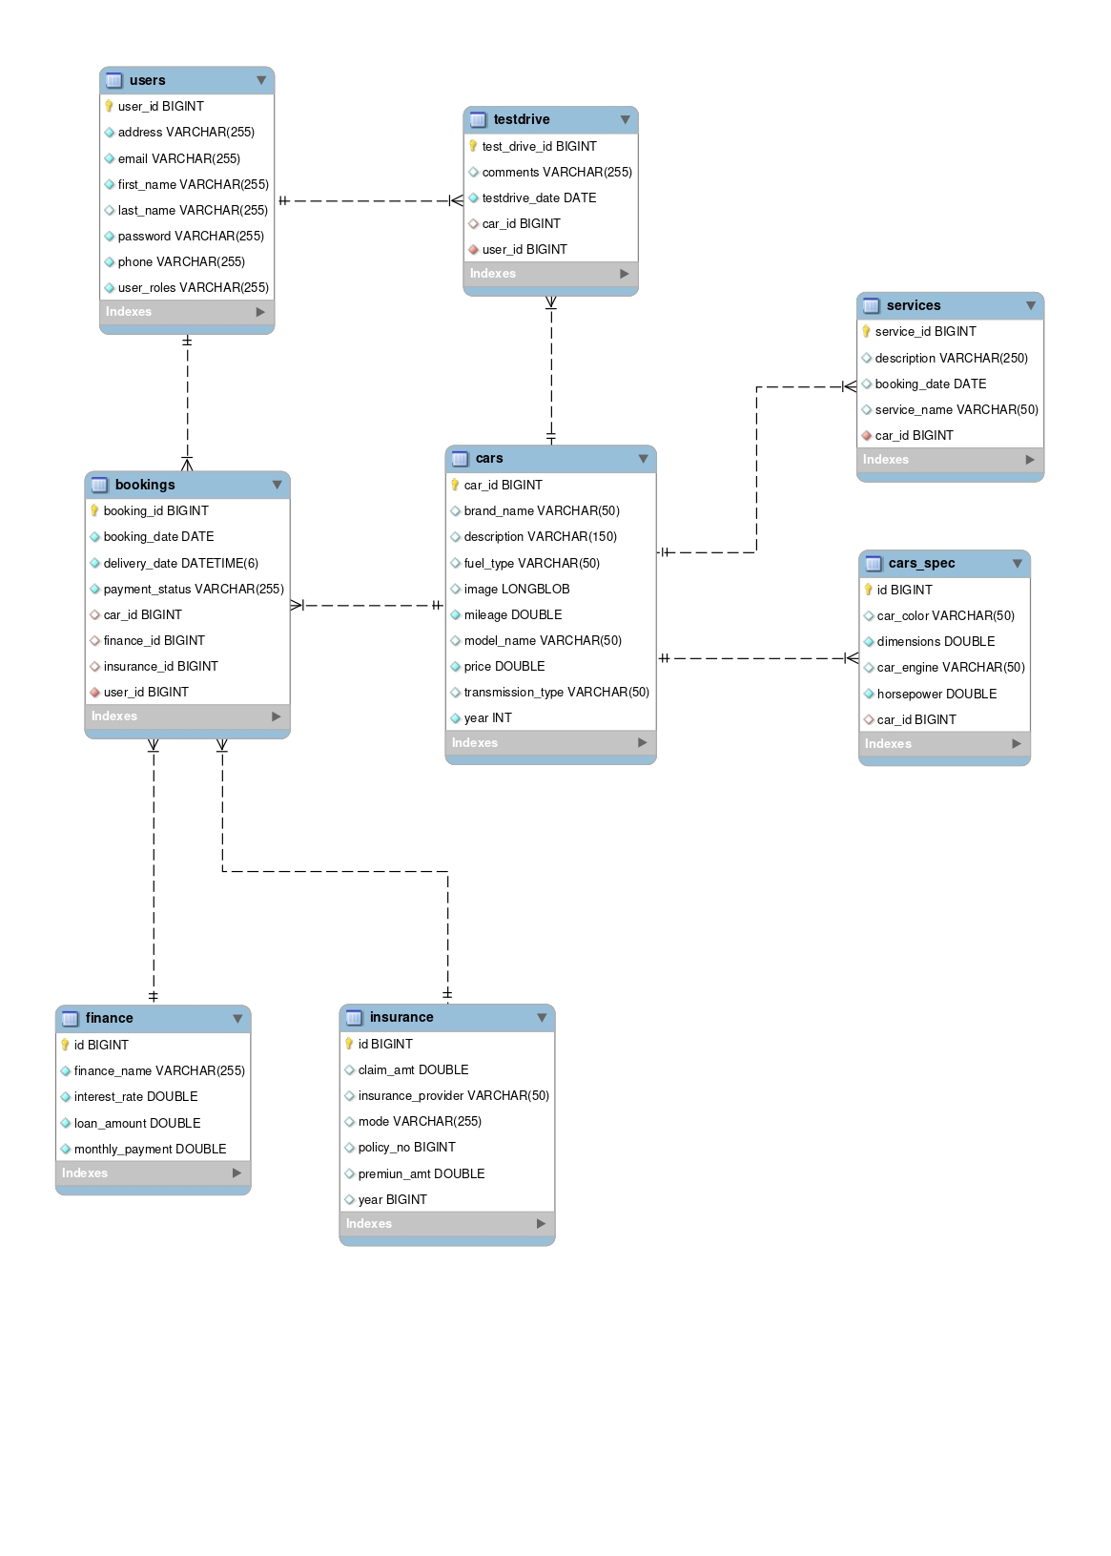

**Class Diagram:**

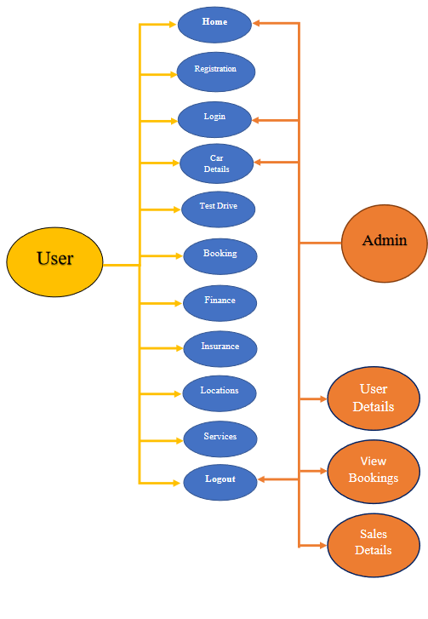

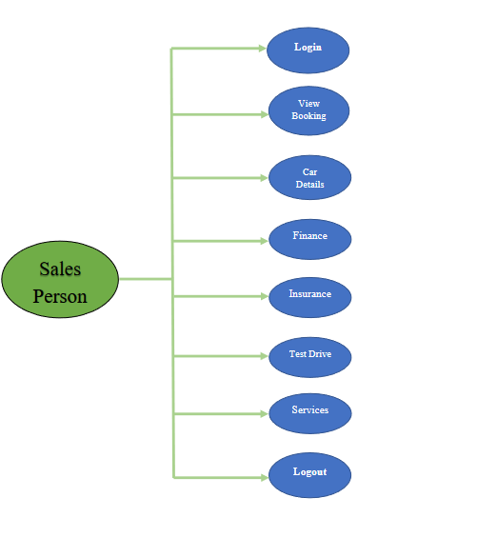

# Appendix B

## Homepage:

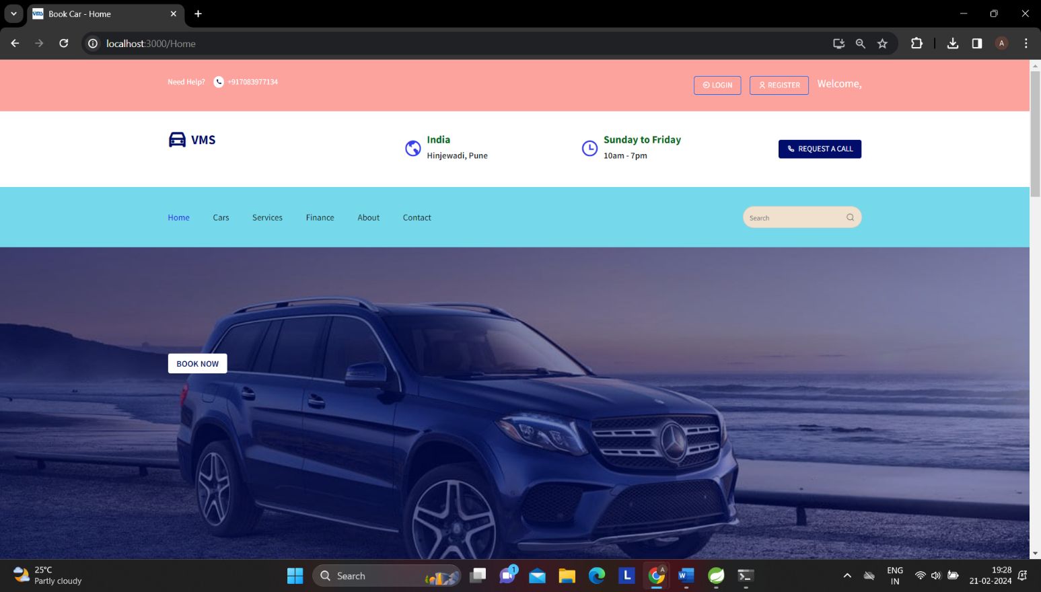

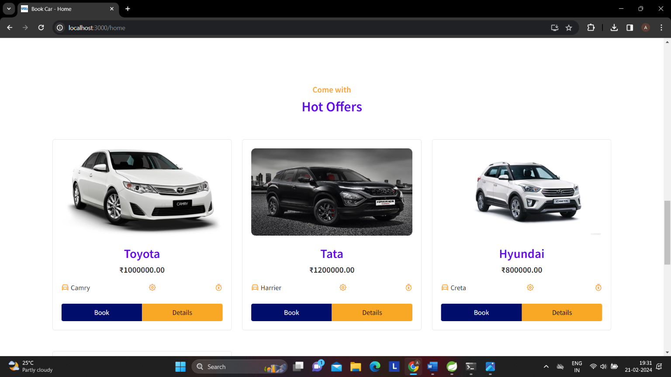

**Register:**

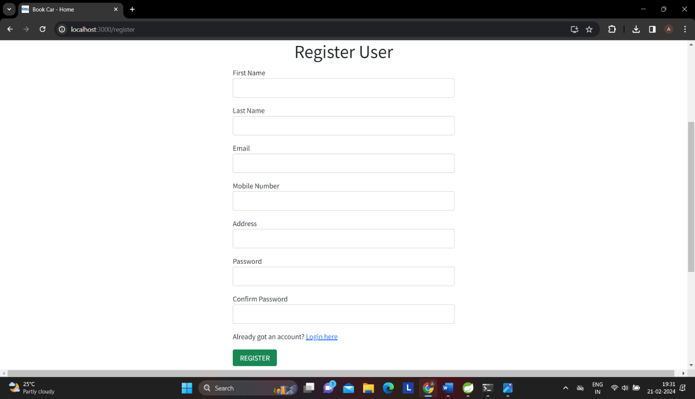

**Login:**

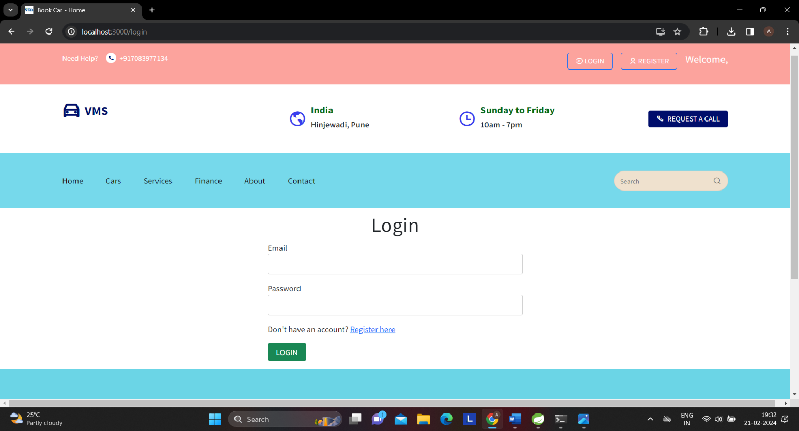

## Admin Dashboard:

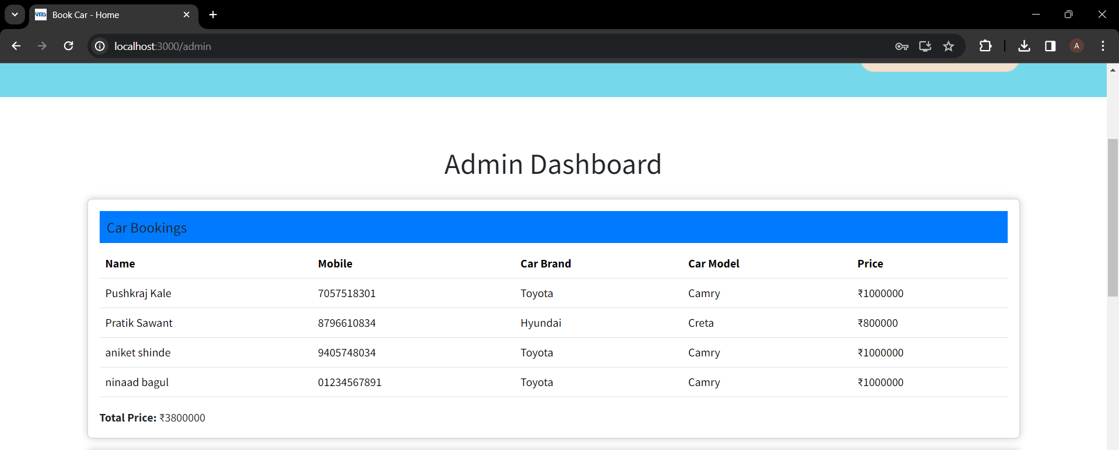

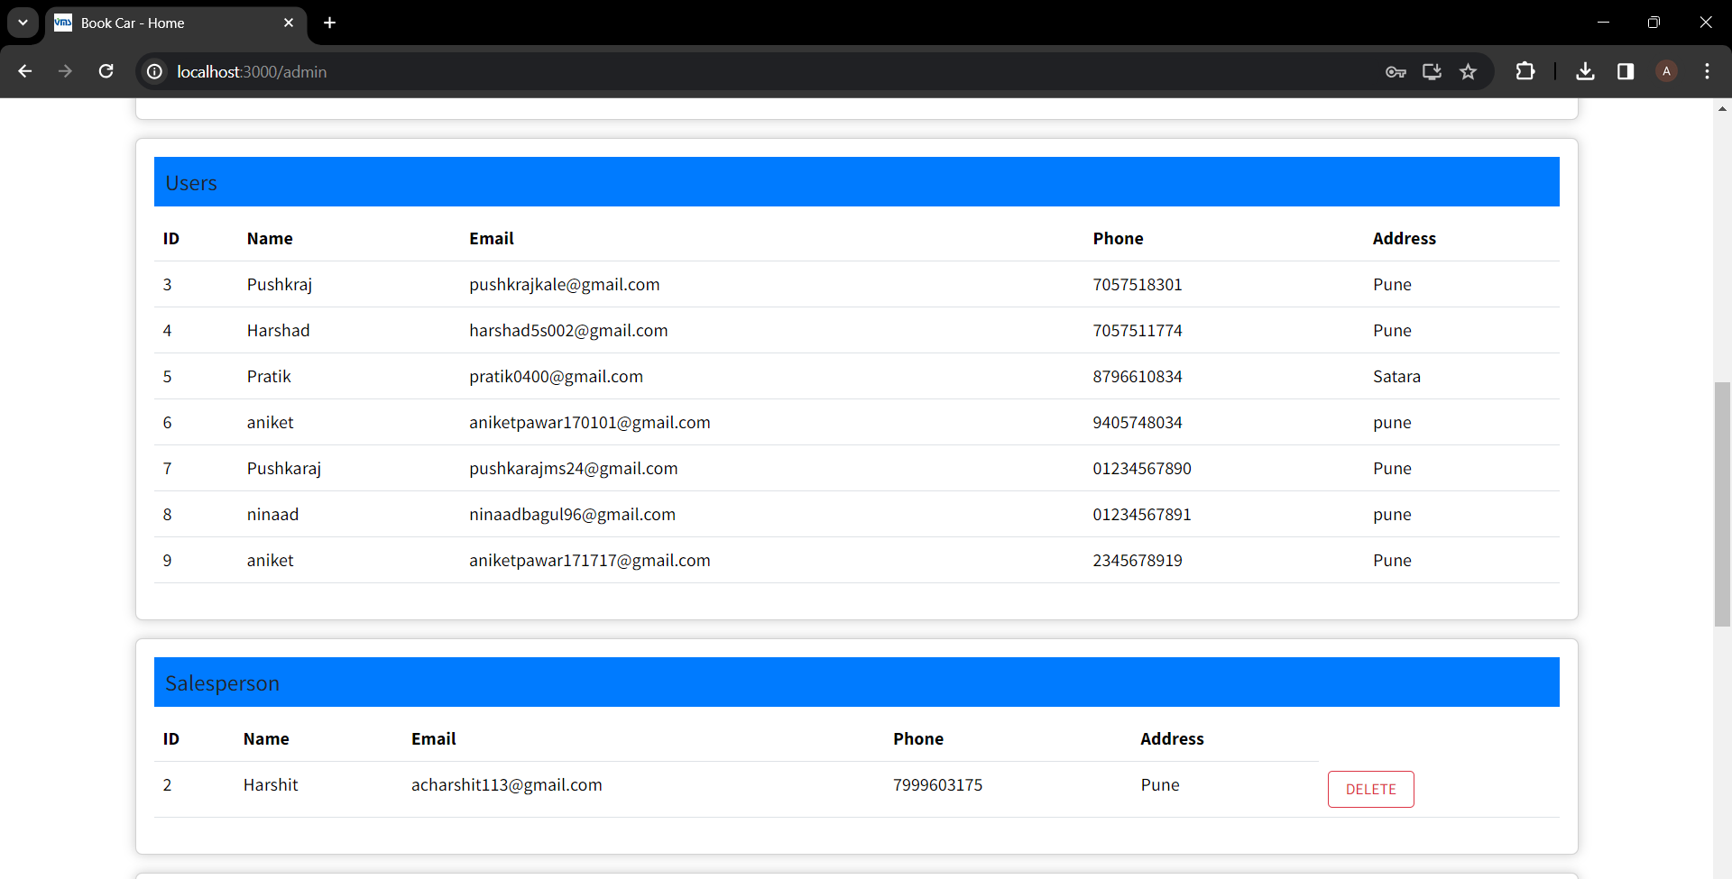

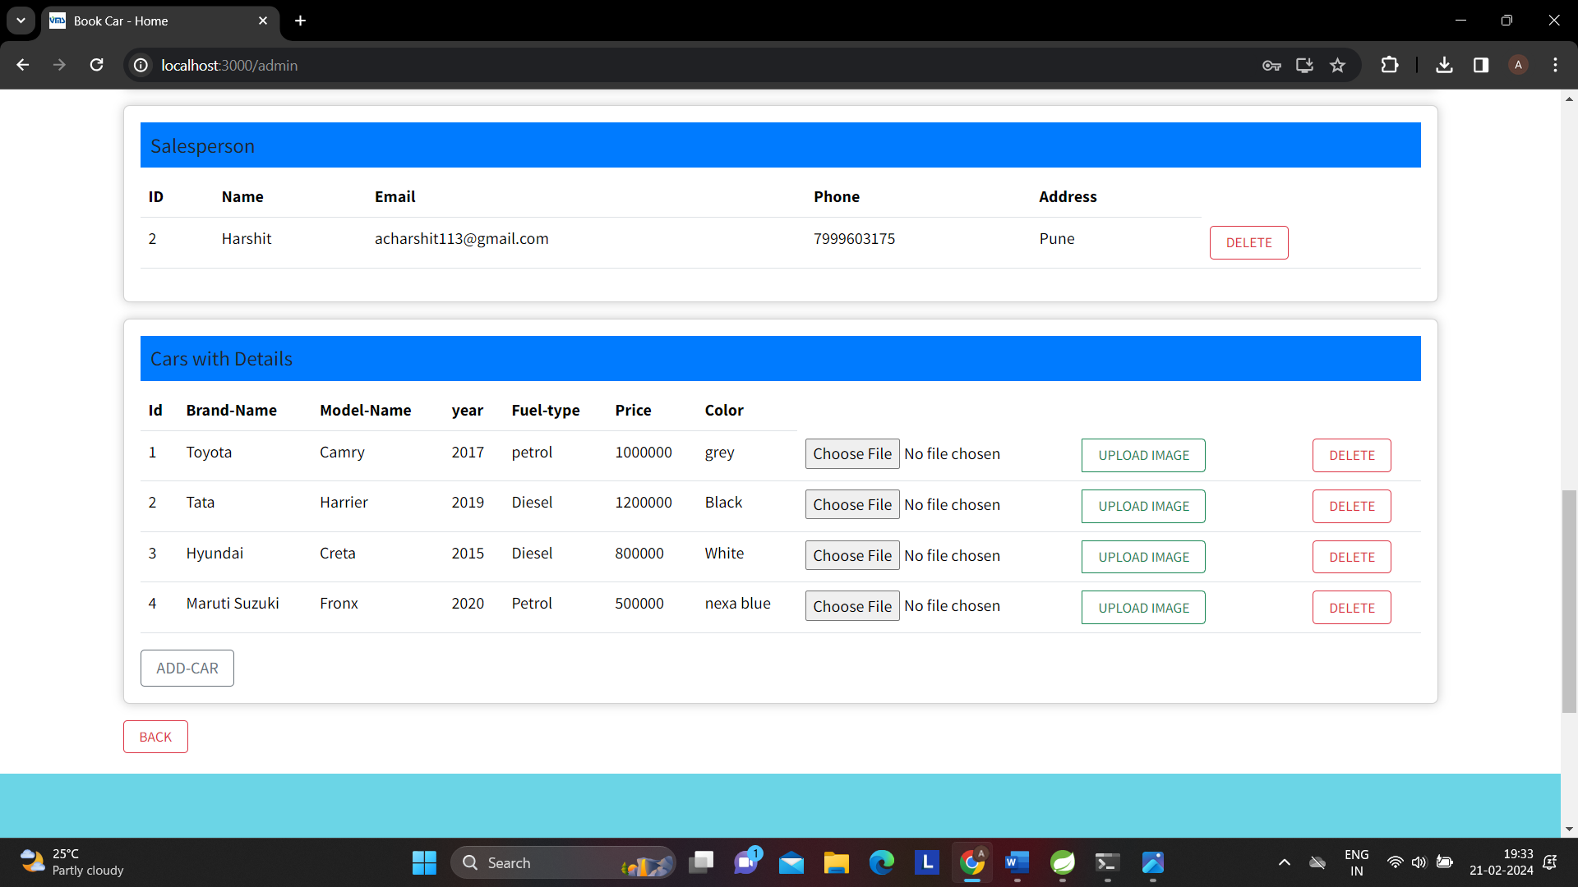

## Salesperson Dashboard:

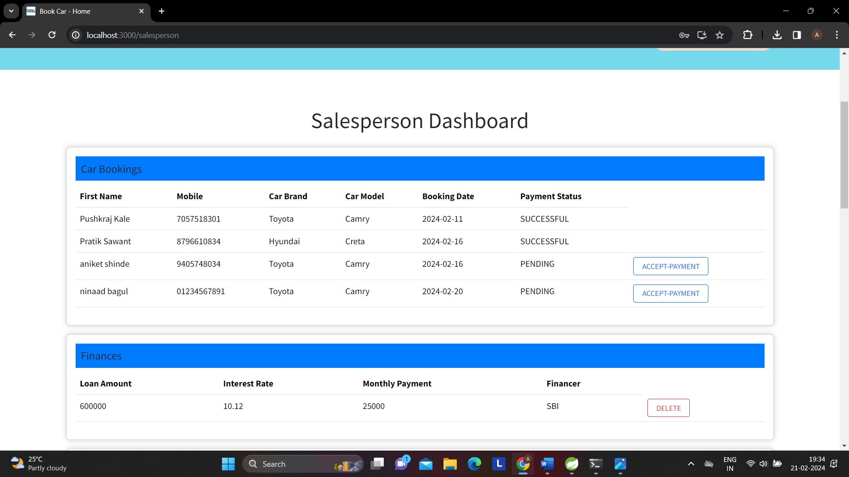

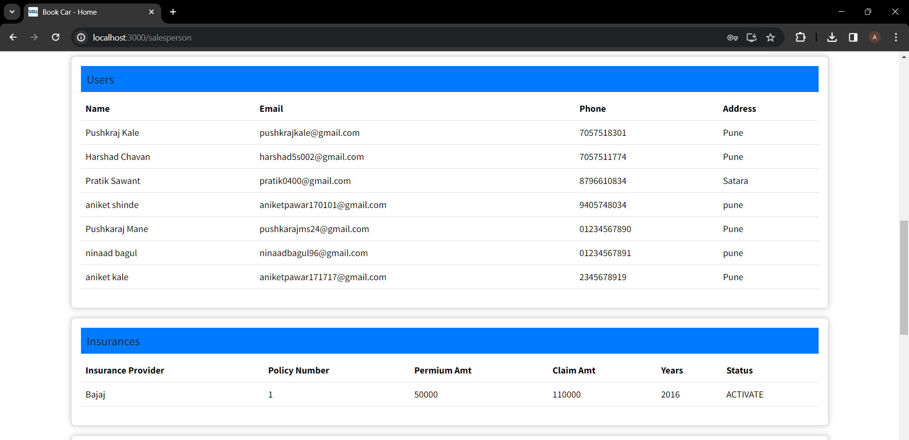

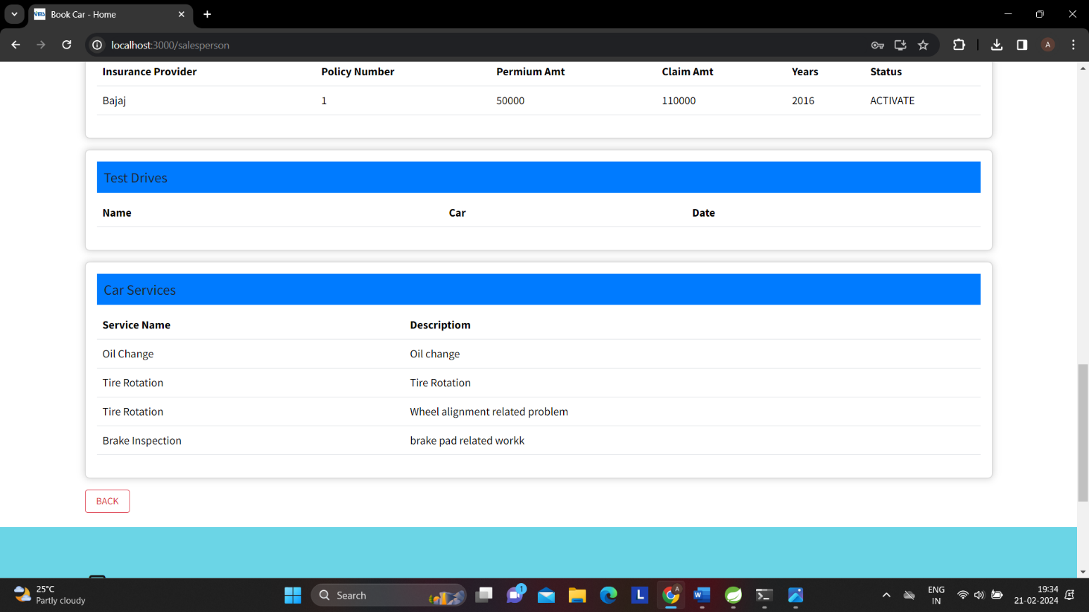

## Car Listing:

## 

## Car Details:

## 

## Booking:

## 

## 

## Test Drive:

## 

## Services:

## 

## Finance:

## 

## About Us:

## 

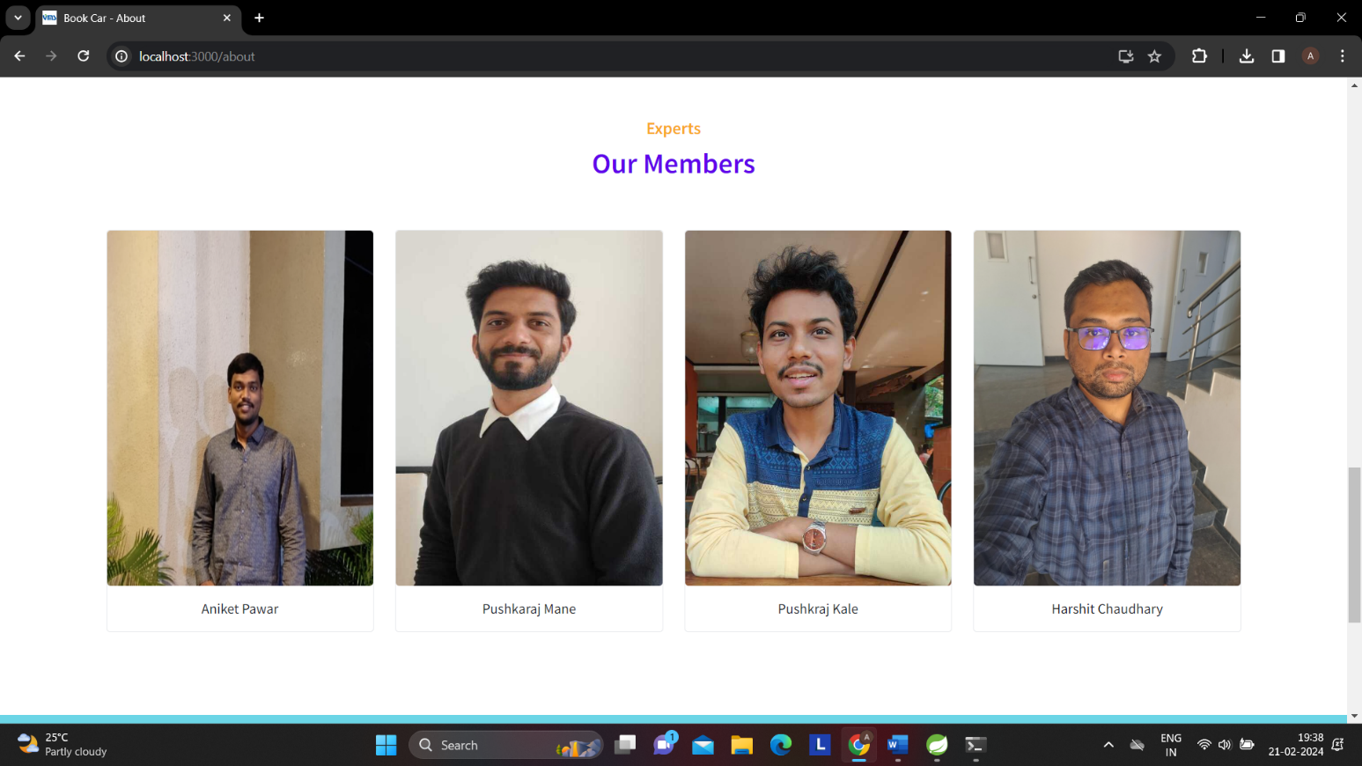

## Contact:

## 

REFERENCES:

[http://www.google.com](http://www.google.com/) <http://www.javatpoint.com/java-tutorial> [http://www.w3.org](http://www.w3.org/) [http://www.wikipedia.org](http://www.wikipedia.org/) <https://www.tutorialspoint.com/java/>

<http://www.tutorialspoint.com/mysql/>